
Spirometry and Reversibility

If you have an inhaler(s) please do NOT use this prior to your test.
SABA- do not use for 4-6 hours prior to test
SAMA- do not use for 12 hours prior to test
LABA- do not use for 24 hours prior to test
Ultra LABA- do not use for 36 hours prior to test
LAMA- do not use for 36-48 hours prior to test
STEROID- do not use for 24 hours prior to test

If you are unsure which type of inhaler(s) you have, please contact us ASAP before your appointment so that we can advise accordingly.
Please note that these are clinical guidelines- in the interest of patient safety, you can still take your inhalers if clinically warranted.

Please also avoid the following prior to your test:
- Smoking on the day of testing
- Consuming alcohol for at least 4 hours prior to the test
- Eating a substantial meal for at least 2 hours prior to the test
- Vigorous exercise for at least 30 minutes prior to the test
- Wearing tight clothing

After the first part of the test, you will be placed on a NEBULISER for approximately 10 minutes, where you will breathe in a bronchodilator.
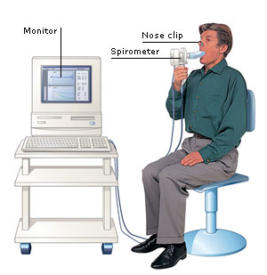
This test will measure how well your lungs are working before and after taking the medication. We will measure your height and weight prior to the test. You will be asked to take a deep breath in and blow it all out hard and fast through a tube connected to a lung function computer. You will then be placed on a nebuliser for approximately 10 minutes, where you will breathe in a bronchodilator (salbutamol or terbutaline) as an aerosol. Once nebulisation is complete, you will wait a further 15 minutes. The lung function test will then be repeated. You will be seated during the test as the hard and fast blowing can make you feel temporarily lightheaded. You will not be required to remove any clothing for the lung function test and it takes on average 45-60 minutes to complete.

Prior to the test we will obtain your pulse rate and oxygen saturation levels via a pulse oximeter- please avoid wearing false nails or coloured nail varnish as this can produce inaccurate results and we may not be able to proceed with the test.

This test may be performed by either a male or female member of staff. If you require a chaperone, please contact us as soon as possible prior to your appointment so that we may arrange this. Alternatively, you may prefer to have a relative accompany you.

NOTE: Please notify us in the first instance if you currently have or have had any of the following:

- Active untreated TB

- Aortic or cerebral aneurysm >6cm or bulging

- Untreated pulmonary embolism

- Eye or facial surgery within the last 2-6 weeks

- Unstable angina/angina attack and have used your GTN spray prior to testing

- Recent MI (heart attack) in the last 7 days

- Pneumothorax (collapsed lung) within the last 3 weeks

- Brain surgery in the last 3-6 weeks

- Abdominal or thoracic surgery within the last 4 weeks

- Vascular surgery in the last 4-6 weeks

- Nausea, vomiting or diarrhoea

- Middle ear infection which has not been treated

- Haemoptysis (coughing up of blood)

- Stroke which has not been treated

- A chest infection whether or not it has been treated with antibiotics

- A previous reaction or known allergy to Salbutamol or Terbutaline

