Resting 12-Lead Electrocardiogram (ECG)

You have been scheduled for a Resting 12-Lead Electrocardiogram (ECG) test at Express Diagnostics. This is a simple and painless test that records the electrical activity of your heart, including the rate and rhythm. The average duration of the appointment is 20 minutes.

Why is a Resting 12-Lead ECG done?
A 12-lead resting ECG is performed to provide a detailed view of your heart’s electrical activity. It helps healthcare professionals detect irregularities, assess heart health, and guide treatment plans.

Preparing for your Resting 12-Lead ECG
Here are some things you can do to prepare for your ECG:
- Wear a top that’s easy to take on and off.
- Ensure you wash thoroughly prior to your appointment
- Avoid applying body lotions, oils, or talcum powder on your skin before the test.
- Some people may want to shave their chest if they are particularly hairy.
- If you have a pacemaker, please inform us and bring your pacemaker card if you have it.

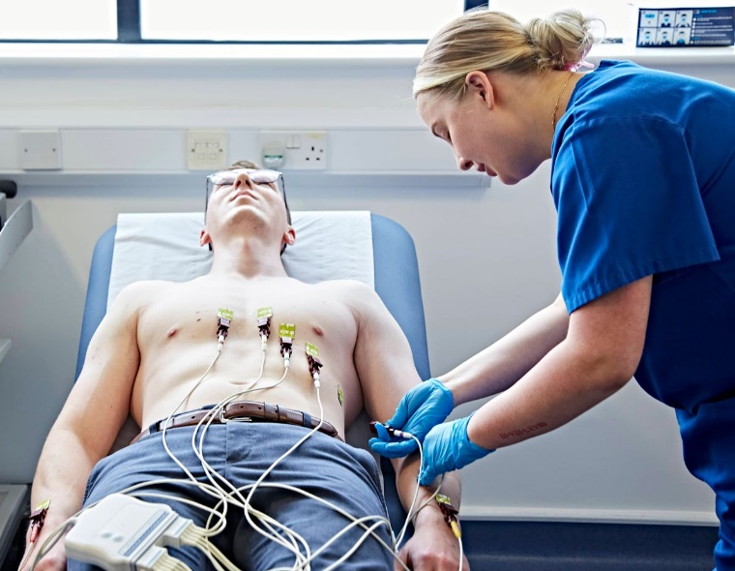
What happens during a Resting 12-Lead ECG?
A Resting 12-lead ECG is done by a trained healthcare professional at Express Diagnostics. During this test, you will be asked to undress to the waist and will be required to remove your bra and tights if applicable. You will be asked to lie down while leads are attached to your arms, legs, and chest. These leads record the electrical activity of your heart while you are at rest.
Please make sure to remain still while the ECG is being recorded to ensure accurate results.
Please inform us ahead of time if you need a chaperone or prefer a healthcare professional of a specific gender. Note that same-day requests may necessitate rescheduling to accommodate your needs.

